**Topic:** Need Finding

**Target Audience:** Lunch Goers (Students/Faculty)

**Questions:**

* What are your thoughts on the allotted time for lunch breaks, is it enough?
* How do you spend your breaks?
* Are the food choices on the cafeteria enough?
* How about the food line queuing?
* What are the reasons for you not to eat at the cafeteria, and where do you usually eat out?

**User Needs:**

Based on our interviewed people’s responses. Their lunch time is more than enough however the time with the other classes like example Senior Highschool’s break time tend to interrupt their own break time and caused them to queue more students in the line. Then in that case, they tend to leave the campus to eat somewhere outside since or some will not eat lunch and just hang out with their friends.

* Enough time for breaks
* Food line queueing
* Variety of food
* Volume of students (Lunch Goers) should be taken to consideration in regards of cafeteria availability
* Why students choose to eat out of the campus

**Point of View:**

* Crowded cafeteria / No seats available, Eat out
* Boring foods menu, Check and order online
* Expensive food, Go eat at a karinderya

Documentation:

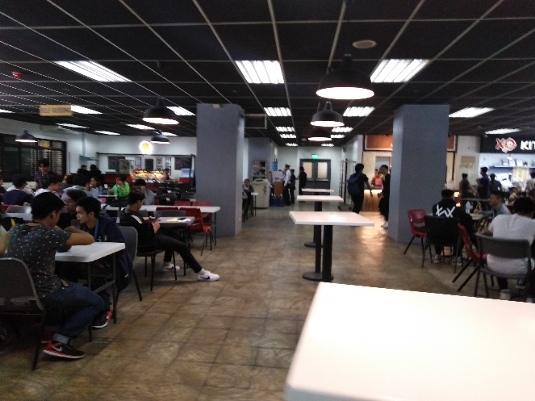 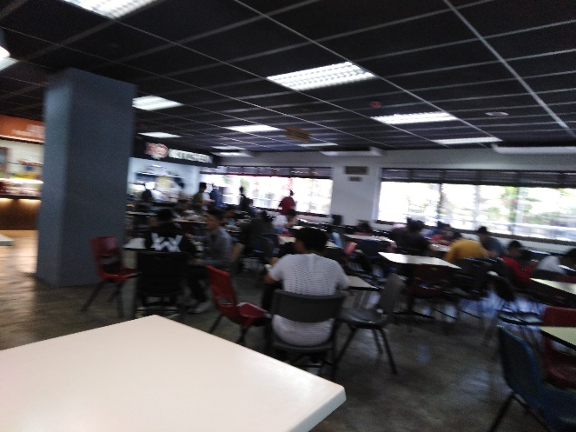

**Members:**

Maga, Katrina Kin

Lapuz, Karlvin

**Paper Prototype (Revised):**

JOLLIBEE

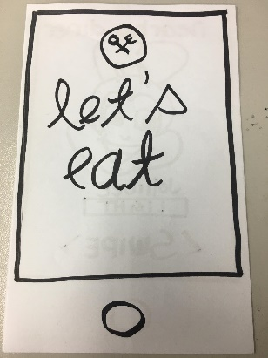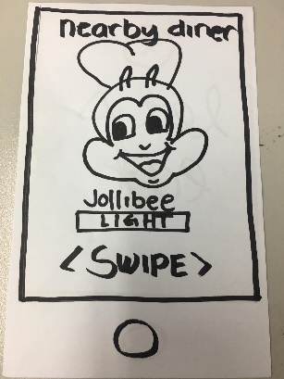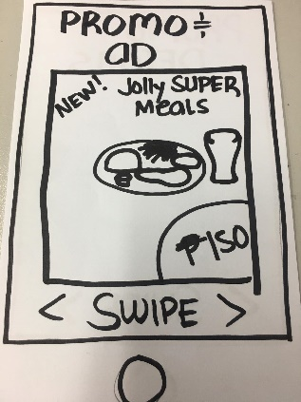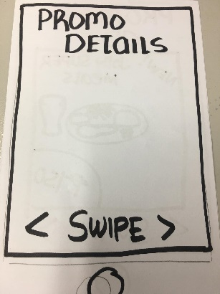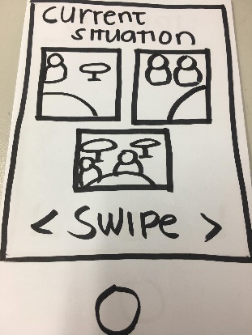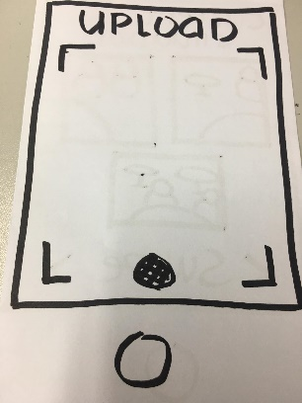

MAX’S

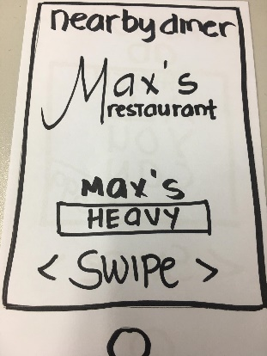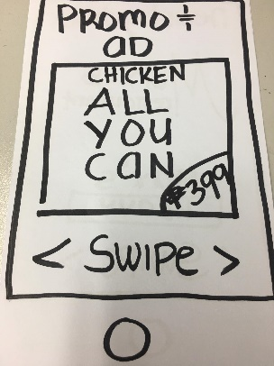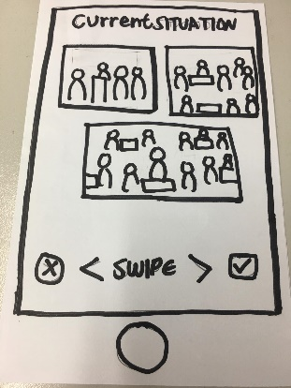

**Digital Mockup (Paper Prototype):**

**JOLLIBEE**

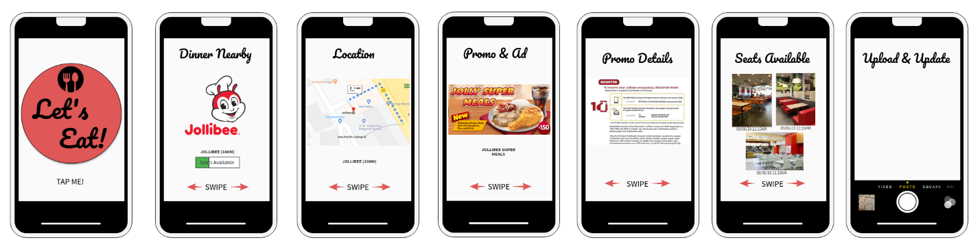

**MAX’S RESTAURANT**

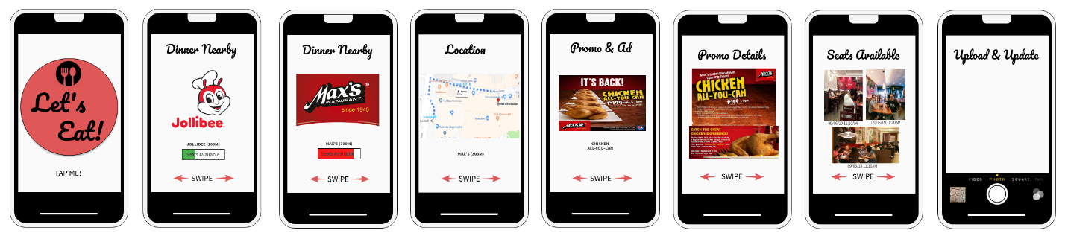

**FEEDBACK:**

**INTERVIEW#1:**

**Convenient. Kasi yong UI niya parang “TINDER” lang swipe right kapag gusto mo, swipe left kapag ayaw mo. So Okay yon, at saka nakalagay doon yong promo ano yong mga meron saka nakikita mo yong seat placements. Kaya okay siya sakin.**

**INTERVIEW#2:**

**Swipe on the bottom side is a little redundant but I understand why it’s there, for further instructions. But overall I like the idea and its UI is very simple and it also suggests the nearest restaurant available which is nice.**

**Key take-aways:**

* **Convenient**
* **UI is User-Friendly**
* **Good additions such as: Promo Inclusions, Seat placements, Suggests nearest restaurant**